LEBRIKIZUMAB ▼
EBGLYSS ®
LEBRIKIZUMAB (EBGLYSS ®) is indicated for the treatment of moderate-to-severe atopic dermatitis in adults and adolescents of 12 years or older with a body weight of at least 40 kg who are candidates for systemic therapy¹

Dosing
500 mg (two 250 mg injections) at both week 0 and week 2, followed by 250 mg administered subcutaneously every other week (Q2W) up to week 16 (figure 1).¹ After week 16, the recommended maintenance dose is 250 mg every four weeks (Q4W) upon achieving response. Consideration should be given to discontinuing treatment in patients who do not respond after 16 weeks, but some patients with partial response may benefit from continued Q2W treatment up to week 24.
Figure 1. Recommended dosing of LEBRIKIZUMAB.
Mechanism of Action
Interleukin-13 (IL-13) is a pro-inflammatory cytokine in the skin and plays a central role in the pathophysiology of atopic dermatitis (AD).² Research indicates that IL-13 levels are elevated in skin biopsies from AD patients, both in lesional and non-lesional skin.³ These levels correlate with the severity and chronicity of AD, and IL-13 has been detected in skin biopsies from early childhood to adulthood in AD patients.^{5,6}

LEBRIKIZUMAB is an antibody that binds with high affinity to IL-13,⁷ and selectively inhibits IL-13 signaling through the IL‐4Rα/IL‐13Rα1 receptor complex, while IL-4 signaling remains unaffected (figure 2).⁷⁻⁹ IL-13Rα2 receptor acts as a decoy receptor, contributing to regulating IL-13 levels, and LEBRIKIZUMAB does not affect the binding of IL-13 to IL-13Rα2.⁷
Figure 2. Mechanism of LEBRIKIZUMAB. Figure adapted from Bieber 2021 and Moyle 2019.^{2,12}

Efficacy Data
LEBRIKIZUMAB as monotherapy was evaluated against placebo in two phase 3 studies: ADvocate 1 and 2^{1,13} In the ADvocate studies, patients were randomized to either placebo or 250 mg LEBRIKIZUMAB every other week (Q2W) for a period of 16 weeks.¹³ Both studies achieved their primary endpoints at week 16, with a statistically significant proportion of patients achieving EASI 75 compared to placebo (52-59% vs. 16-18%, tabel 1, figure 3a og 3b). Patients treated with LEBRIKIZUMAB also achieved significant improvements of ≥4 points in DLQI (66-76% vs. 34% placebo) and pruritus NRS (40-46% vs. 12-13% placebo, tabel 1).
Tabel 1. Efficacy of 250 mg LEBRIKIZUMAB monotherapy at week 16 og week 52 for patients with response to treatment at week 16.^{13,14}
 | Week 16 |  |  |  | Week 52
 | ADvocate 1 |  | ADvocate 2 |  | ADvocate 1+ 2
 | PBO | Q2W | PBO | Q2W | PBO | Q4W
% EASI 75ª | 16 | 59*** | 18 | 52*** | 66 | 82*
% DLQI^{b} | 34 | 76*** | 34 | 66*** | n.r. | n.r.
% pruritus NRS^{c} | 13 | 46*** | 12 | 40*** | 66 | 85
n = | 141 | 283 | 146 | 281 | 60 | 109
ª Week 16 data: Participants with a 75% reduction in EASI from baseline.
Week 52 data: Participants with an EASI 75 response at week 16 who maintained response at week 52.
^{b} % patients with ≥ 4-point improvement . Only participants with a baseline DLQI ≥ 4 were included.
^{c} % patients with ≥ 4-point improvement. Only participants with a baseline Pruiritus NRS ≥ 4 were included.
* p < 0,05 versus placebo, *** p < 0,001 versus placebo, n.r. not reported
Patients who responded to 250 mg Q2W LEBRIKIZUMAB treatment at week 16 were re-randomized to placebo and 250 mg Q2W or Q4W.^{1,14} Treatment response was defined as EASI 75 and/or IGA 0/1 without use of local or systemic rescue therapy. After 52 weeks, 82% and 78% of patients treated with 250 mg LEBRIKIZUMAB Q4W and Q2W respectively maintained EASI 75, while 66% of patients receiving placebo maintained EASI 75 (tabel 1, figure 3c).
a) | 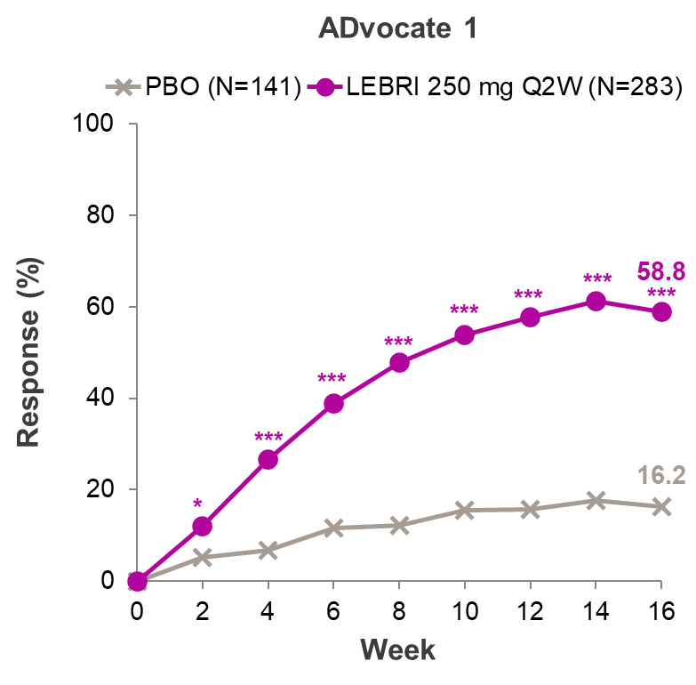 | b) | 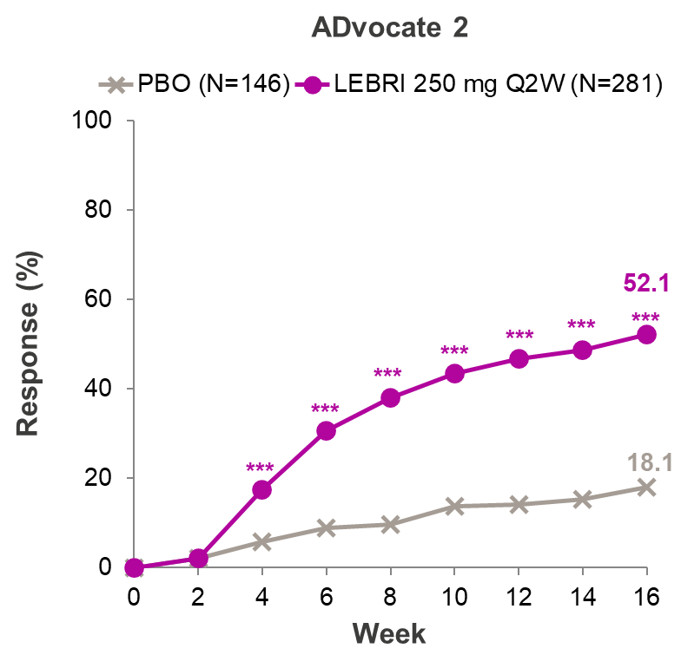
c) | 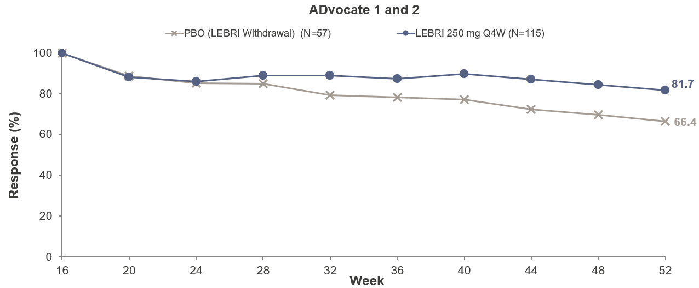
Figure 3. EASI 75 response in ADvocate monotherapy studies at week 16 and 52.^{13,14} *p ≤ 0,05, **p ≤ 0,01, ***p ≤ 0,001 versus placebo.

LEBRIKIZUMAB in combination with topical corticosteroids (TCS) treatment was evaluated in the ADhere study.^{1,15} In ADhere, patients were randomized to either placebo +TCS or 250 mg LEBRIKIZUMAB Q2W +TCS for 16 weeks.¹⁵ At week 16, a statistically significant proportion of patients treated with LEBRIKIZUMAB +TCS achieved improvement in EASI 75 compared to placebo +TCS (70% vs. 42%). (figure 4, tabel 2). Patients treated with LEBRIKIZUMAB +TCS also achieved significant improvements in DLQI (77% vs. 59% placebo) and pruritus NRS (51% vs. 32% placebo) (tabel 2).
Tabel 2. Efficacy of 250 mg LEBRIKIZUMAB combination therapy with TCS at week 16 (ADhere).¹⁵
 | PBO + TCS | Q2W + TCS
% EASI 75ª | 42 | 70***
% DLQI^{b} | 59 | 77*
% pruritus NRS^{c} | 32 | 51*
n = | 66 | 145
ª Participants with a 75% reduction in EASI from baseline.
^{b} ≥ 4-point improvement . Only participants with a baseline DLQI ≥ 4 were included.
^{c} ≥ 4-point improvement. Only participants with a baseline Pruiritus NRS ≥ 4 were included.
* p < 0,05 versus placebo, *** p < 0,001 versus placebo

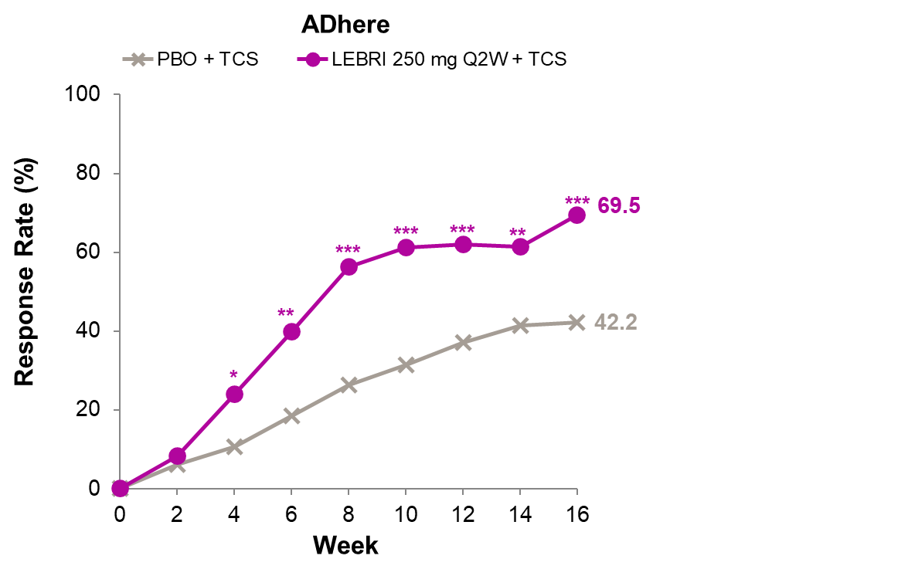
Figure 4. EASI 75 response in ADhere +TCS study at week 16 and 52.¹⁵ *p≤0,05, **p≤0,01, ***p≤0,001 versus placebo.
Safety Data¹
During the clinical studies for atopic dermatitis, a total of 1,720 patients received LEBRIKIZUMAB, of whom 891 patients were treated with LEBRIKIZUMAB for at least one year. The frequencies of adverse reactions are based on data from a group of four randomized, double-blind studies in patients with moderate to severe AD. In these studies, 783 patients were treated with subcutaneous LEBRIKIZUMAB during the placebo-controlled period (the first 16 weeks of treatment).

The most common adverse reactions included conjunctivitis (6.9%), injection site reactions (2.6%), allergic conjunctivitis (1.8%), and dry eyes (1.4%).

During the first 16 weeks of treatment, conjunctivitis, allergic conjunctivitis, blepharitis, and keratitis were reported more frequently in patients treated with LEBRIKIZUMAB (6.9%, 1.8%, 0.8%, and 0.6%, respectively) compared to placebo (1.8%, 0.7%, 0.2%, and 0.3%). In the maintenance treatment period (week 16-52), the incidence of conjunctivitis and allergic conjunctivitis with LEBRIKIZUMAB was 5.0% and 5.9% respectively.

Across all clinical studies, LEBRIKIZUMAB-treated patients experienced treatment discontinuation due to conjunctivitis and allergic conjunctivitis in 0.7% and 0.3% of cases, respectively. Severe cases of conjunctivitis and allergic conjunctivitis were reported in 0.1% and 0.2% of cases respectively. 72% of patients recovered, with 57% recovering within 90 days

Contact Information
If you require more information about LEBRIKIZUMAB, please feel free to contact us:

Antonio Sarno (in-field medical advisor)
antonio.sarno@almirall.com | (+47) 47173735

Elisabeth Hjardem Taudorf (in-field medical advisor)
elisabethhjardem.taudorf@almirall.com | (+45) 61683531

Plikttekst for LEBRIKIZUMAB/EBGLYSS
▼ [abbreviated product information]

Referances

- European Medicines Agency. EBGLYSS preparatomtalen [Internet]. 2023 [cited 2024 Jan 2]. Available from: https://www.ema.europa.eu/no/documents/product-information/EBGLYSS-epar-product-information_no.pdf
- Bieber T. Interleukin-13: Targeting an underestimated cytokine in atopic dermatitis. Allergy. 2020 Jan;75(1):54-62.
- Suárez-Fariñas M, Tintle SJ, Shemer A, Chiricozzi A, Nograles K, Cardinale I, et al. Nonlesional atopic dermatitis skin is characterized by broad terminal differentiation defects and variable immune abnormalities. J Allergy Clin Immunol. 2011 Apr;127(4):954-64.e1-4.
- La Grutta S, Richiusa P, Pizzolanti G, Mattina A, Pajno GB, Citarrella R, et al. CD4(+)IL-13(+) cells in peripheral blood well correlates with the severity of atopic dermatitis in children. Allergy. 2005 Mar;60(3):391-5.
- Renert-Yuval Y, Del Duca E, Pavel AB, Fang M, Lefferdink R, Wu J, et al. The molecular features of normal and atopic dermatitis skin in infants, children, adolescents, and adults. J Allergy Clin Immunol. 2021 Jul;148(1):148-63.
- Czarnowicki T, He H, Canter T, Han J, Lefferdink R, Erickson T, et al. Evolution of pathologic T-cell subsets in patients with atopic dermatitis from infancy to adulthood. J Allergy Clin Immunol. 2020 Jan;145(1):215-28.
- Okragly AJ, Ryuzoji A, Wulur I, Daniels M, Van Horn RD, Patel CN, et al. Binding, Neutralization and Internalization of the Interleukin-13 Antibody, LEBRIKIZUMAB. Dermatol Ther (Heidelb). 2023 Jul;13(7):1535-47.
- Heeb LEM, Boyman O. Comprehensive analysis of human IL-4 receptor subunits shows compartmentalization in steady state and dupilumab treatment. Allergy. 2023 Apr;78(4):1073-87.
- Gonçalves F, Freitas E, Torres T. Selective IL-13 inhibitors for the treatment of atopic dermatitis. Drugs Context. 2021;10:2021-1-7.
- Andrews AL, Nasir T, Bucchieri F, Holloway JW, Holgate ST, Davies DE. IL-13 receptor alpha 2: a regulator of IL-13 and IL-4 signal transduction in primary human fibroblasts. J Allergy Clin Immunol. 2006 Oct;118(4):858-65.
- Ulzii D, Kido-Nakahara M, Nakahara T, Tsuji G, Furue K, Hashimoto-Hachiya A, et al. Scratching Counteracts IL-13 Signaling by Upregulating the Decoy Receptor IL-13Rα2 in Keratinocytes. Int J Mol Sci. 2019 Jul 6;20(13):3324.
- Moyle M, Cevikbas F, Harden JL, Guttman-Yassky E. Understanding the immune landscape in atopic dermatitis: The era of biologics and emerging therapeutic approaches. Exp Dermatol. 2019 Jul;28(7):756-68.
- Silverberg JI, Guttman-Yassky E, Thaçi D, Irvine AD, Stein Gold L, Blauvelt A, et al. Two Phase 3 Trials of LEBRIKIZUMAB for Moderate-to-Severe Atopic Dermatitis. N Engl J Med. 2023 Mar 23;388(12):1080-91.
- Blauvelt A, Thyssen JP, Guttman-Yassky E, Bieber T, Serra-Baldrich E, Simpson E, et al. Efficacy and safety of LEBRIKIZUMAB in moderate-to-severe atopic dermatitis: 52-week results of two randomized double-blinded placebo-controlled phase III trials. Br J Dermatol. 2023 May 24;188(6):740-8.
- Simpson EL, Gooderham M, Wollenberg A, Weidinger S, Armstrong A, Soung J, et al. Efficacy and Safety of LEBRIKIZUMAB in Combination With Topical Corticosteroids in Adolescents and Adults With Moderate-to-Severe Atopic Dermatitis: A Randomized Clinical Trial (ADhere). JAMA Dermatol. 2023 Feb 1;159(2):182-91.

